13/03/2026
Please complete and return to:  hallmanager@grangeoversandstowncouncil.gov.uk  If you would like to chat about your booking in person or would like to look around the hall prior to booking then feel free to arrange an appointment via email. |  |   Council Offices  Main Street    Grange-over-Sands  Cumbria, LA11 6DP  V.A.T. Reg. No: 164 8707 80  www.grangeoversandstowncouncil.gov.uk  www.victoriahall.info
VICTORIA HALL BOOKING FORM – The Chamber
Please see our Conditions of Hire document.
The information you give in this form is to help us organise your booking, so the more info you can give the better. Filling out and returning the booking form is a requirement before we confirm your booking.
See details of the room here: www.victoriahall.info/rooms/chamber

NB: Your booking is not confirmed until you hear back from us - we might need to add or change details.

Contact Information
Name
Organisation (if applicable)
Postal address
Telephone number
E-mail address
PL Insurance number

Invoice Information, if different from above
Name
Organisation (if applicable)
Postal address
Telephone number
Invoice E-mail address

Details of your hire
Main Event Description
(live music, lecture etc)

Date(s) required
List all dates if a repeat booking
Times required
(inc. get-in, set up and take down)
Main Event Timings
(e.g. - yoga class 2-3pm)
Expected Attendance
Approximate is fine
Room Layout Required - Paid for service
The normal layout is what we call the ‘Default’ layout. See the ‘Default’ layout diagram on our website here: www.victoriahall.info/rooms/chamber.

If you want any other layout, then there are two options:

We can set up the room for you with the designs in the table below - this will incur an extra charge of £20.80 inc. VAT for full set up and take down. If you’d like us to set up the room for you, please write ‘yes’ below the Layout that you’d like and we’ll do the rest.

You can change the room to any layout yourself without charge, but you must put the room back to ‘default’ before you go. All the furniture is light or on wheels, to be as easy as possible to move. All chairs and tables can be easily stored on the landing just outside the room. Failure to put the room back to default at the end of your hire will incur a charge.  If you want to pay GTC staff to set up your room, please indicate your choice of layouts: |  |  | 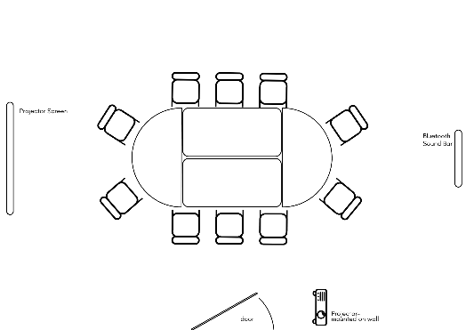  Default Layout:
Lecture - up to 36 chairs  Extra chairs on Landing | Workshop |  | Clear, no tables or chairs | Other:
y/n | y/n |  | y/n | y/n
If ‘Other’, please describe your layout here and if you need help with set up. An additional charge may apply for any set ups that require extra staff time.

Extras - Included in hire
Mark the facilities you’d like to use and give details if possible. Just so we know!
More info can be found here: Additional Info | Victoria Hall
Kitchen | Screen & projector

Refreshments *
£3.25 per head for a DIY hot drinks and biscuits buffet in your room - all day refresh of hot drinks/water and generous biscuit selection. Ask us about our bulk discount packages.
I’d like drinks and snacks for my event | Answer here: (Y/N)
Number of people (we have discount packages for more than 20 people - please ask for more details)

Booking confirmation

By signing below, I agree that:

- I am the hirer or appointed representative of the hirer.
- I have read and agree to all the terms and conditions in the accompanying documents – ‘Conditions of Hire’ and ‘Victoria Hall Fire Safety’.
- I agree to abide by the terms of the ‘key holder policy statement’ (short or long term).
- I agree to follow all guidance given by Town Council staff specific to my event.
- I agree to pay the invoice in full within 30 days of receipt.

Print name: ………………………………………………………………………………………………..

Signed: …………………………………………………………………………………………………………

Dated:

Completed forms to be returned to the Hall Manager: hallmanager@grangeoversandstowncouncil.gov.uk

Privacy:
Grange Town Council will only use any information that you give us to provide services that you request.
For more information see our Privacy Notice www.grangeoversandstowncouncil.gov.uk

