13/03/2026
Please complete and return to:  hallmanager@grangeoversandstowncouncil.gov.uk  If you would like to chat about your booking in person or would like to look around the hall prior to booking, then feel free to arrange an appointment via email. |  |   Council Offices  Main Street    Grange-over-Sands  Cumbria, LA11 6DP  V.A.T. Reg. No: 164 8707 80  www.grangeoversandstowncouncil.gov.uk  www.victoriahall.info

VICTORIA HALL BOOKING FORM – The Old Police Room (Room 4)
Please see our Conditions of Hire document.
The information you give in this form is to help us organise your booking, so the more info you can give the better. Filling out and returning the booking form is a requirement before we confirm your booking.
See details of the room here: www.victoriahall.info/rooms/oldpoliceroom

NB: Your booking is not confirmed until you hear back from us - we might need to add or change details.
Contact Information
Name
Organisation (if applicable)
Address
Telephone number
E-mail address
PL Insurance number

Invoice Information, if different from above
Name
Organisation (if applicable)
Adress
Telephone number
Invoice E-mail address

Details of your hire
Main Event Description
(live music, lecture etc)

Date(s) required
List all dates if a repeat booking
Times required
(inc. get-in, set up and take down)
Main Event Timings

Room Layout Required - Paid for service
The normal layout is what we call the ‘Default’ layout. See the ‘Default’ layout below.

If you want any other layout, then there are two options:

We can set up the room for you with the designs in the table below - this will incur an extra charge of £20.80 inc. VAT for full set up and take down. If you’d like us to set up the room for you, please write ‘yes’ below the Layout that you’d like and we’ll do the rest.

You can change the room to any layout yourself without charge, but you must put the room back to ‘default’ before you go (see image, right). All the furniture is light or on wheels, to be as easy as possible to move. All chairs and tables can be easily stored in the foyer just outside the room. Failure to put the room back to default at the end of your hire will incur a charge. |  | 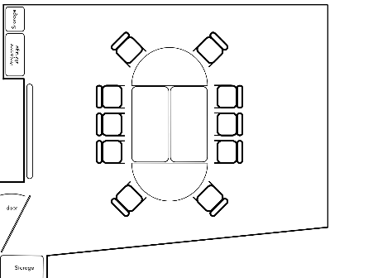
Lecture - up to 20 chairs  Requires some chairs from the Main Hall Store | Workshop | Clear, no tables or chairs | Other:
Y/N | Y/N | Y/N | Y/N
If ‘Other’, please describe your layout here and if you need help with set up. An additional charge may apply for any set ups that require extra staff time.

Extras
Mark the facilities you’d like to use and give details if possible.
The ones with an additional fee are marked with a *.
More info can be found here: Additional Info | Victoria Hall
Kitchen - you are welcome to use our kitchen for free - please clean/dry and put away everything you use, take away all waste and recycling. | Y/N | Screen & projector | Y/N

Refreshments
For £3.25 per head, we can lay out hot drink facilities and cups/saucers for you.
I’d like drinks and biscuits for my event | Yes, Please No, thank you
Number of people

Booking confirmation

By signing below, I agree that:

- I am the hirer or appointed representative of the hirer.
- I have read and agree to all the terms and conditions in the accompanying documents – ‘Conditions of Hire’ and ‘Victoria Hall Fire Safety’.
- I agree to abide by the terms of the ‘key holder policy statement’ (short or long term).
- I agree to follow all guidance given by Town Council staff specific to my event.
- I agree to pay the invoice in full within 30 days of receipt.

Print name: ………………………………………………………………………………………………..

Signed: …………………………………………………………………………………………………………

Dated:

Completed forms to be returned to the Hall Manager

Privacy:
Grange Town Council will only use any information that you give us to provide services that you request.
For more information see our Privacy Notice www.grangeoversandstowncouncil.gov.uk

